***POSTGRESQL Installation Steps on MacOS***

Go to the link <https://www.postgresql.org/>

Click on the Download button as shown

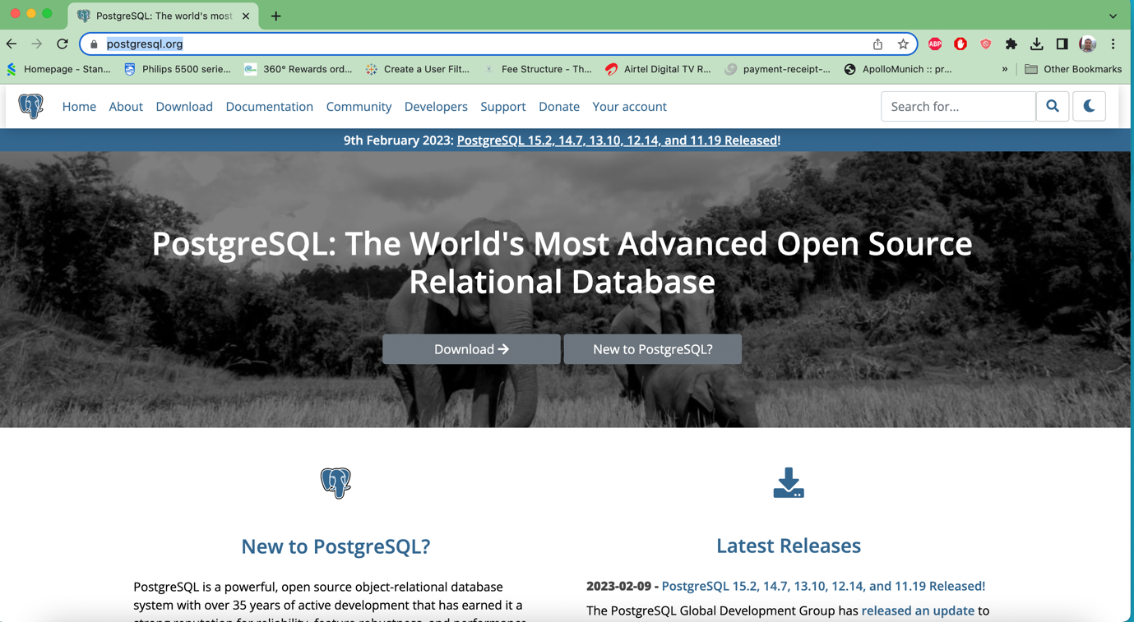

Choose the operating system as macOS

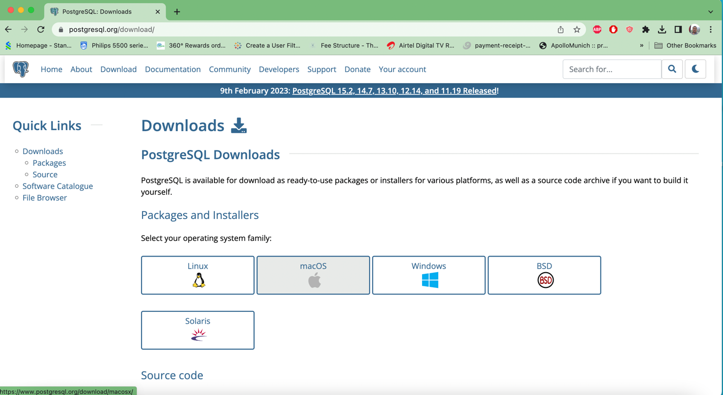

Click on “Download the Installer”

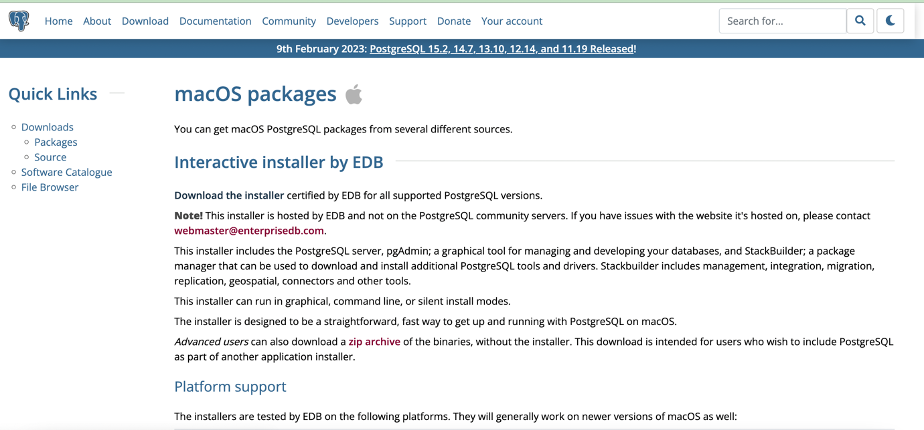

Click on the download icon corresponding to Mac OS X

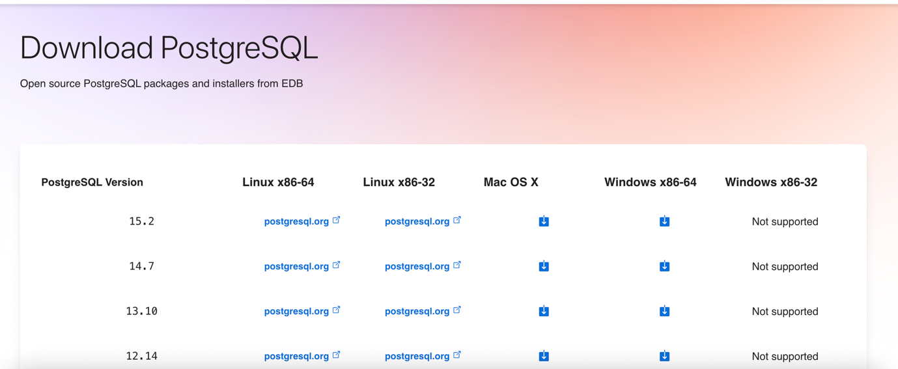

The download will start

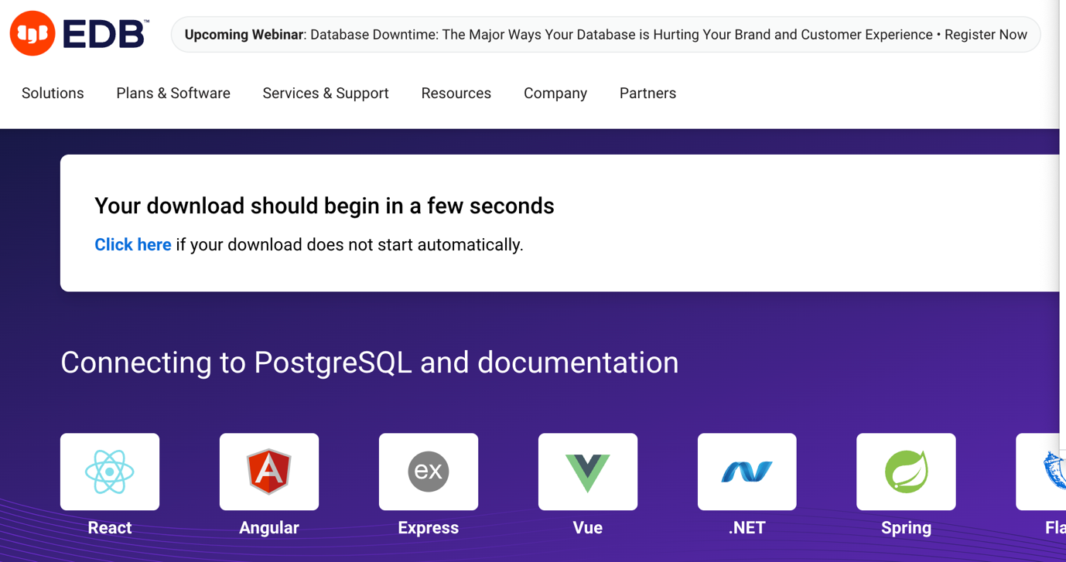

Run the file (double click)

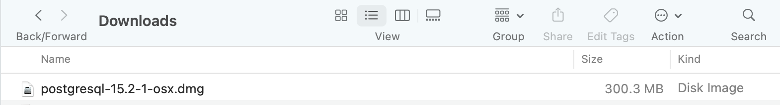

Double click to install

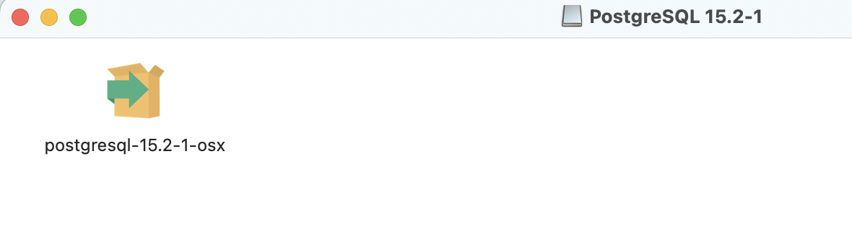

Click on the “Open” button

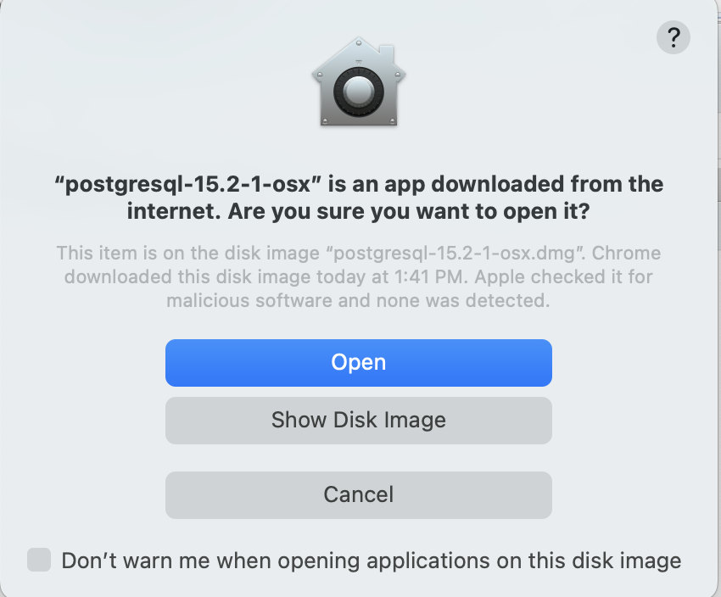

Follow the instructions given in the installation wizard

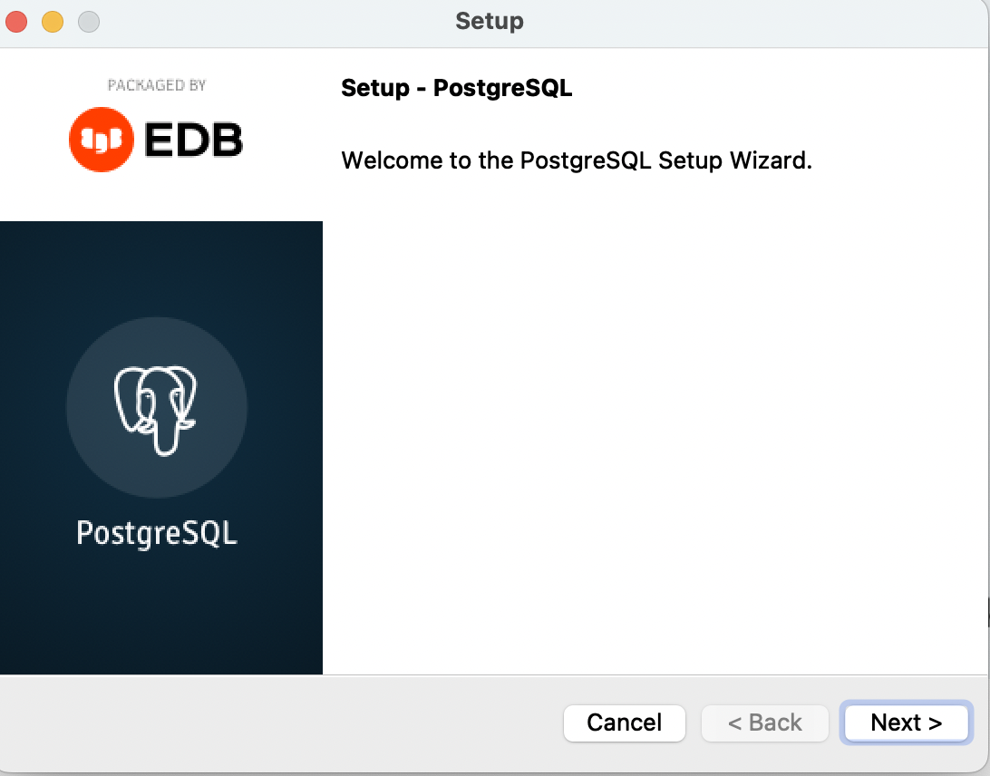

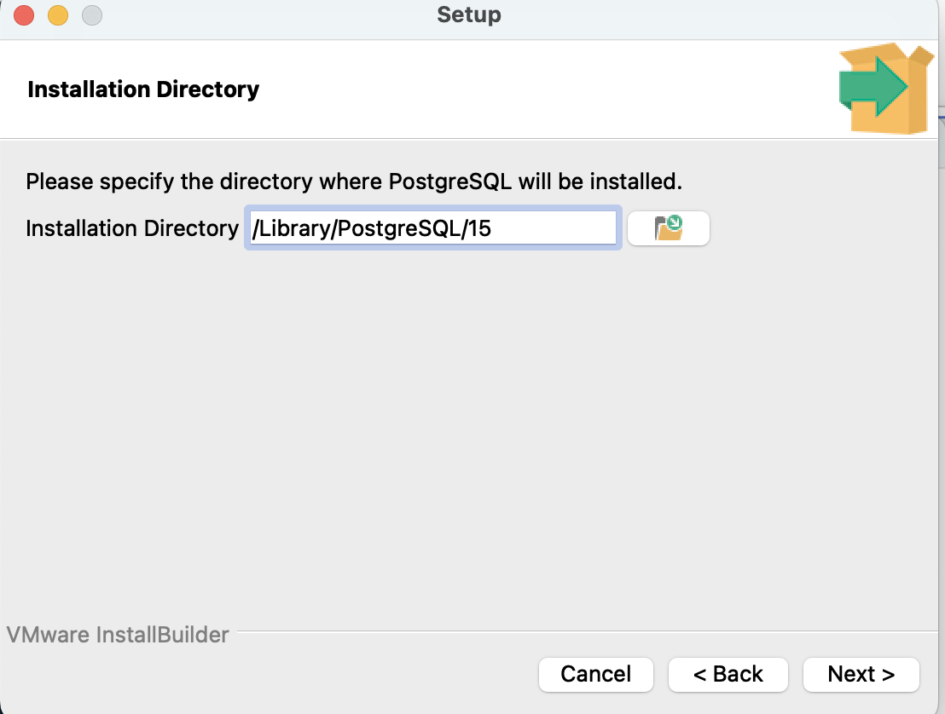

Uncheck “Stack Builder”

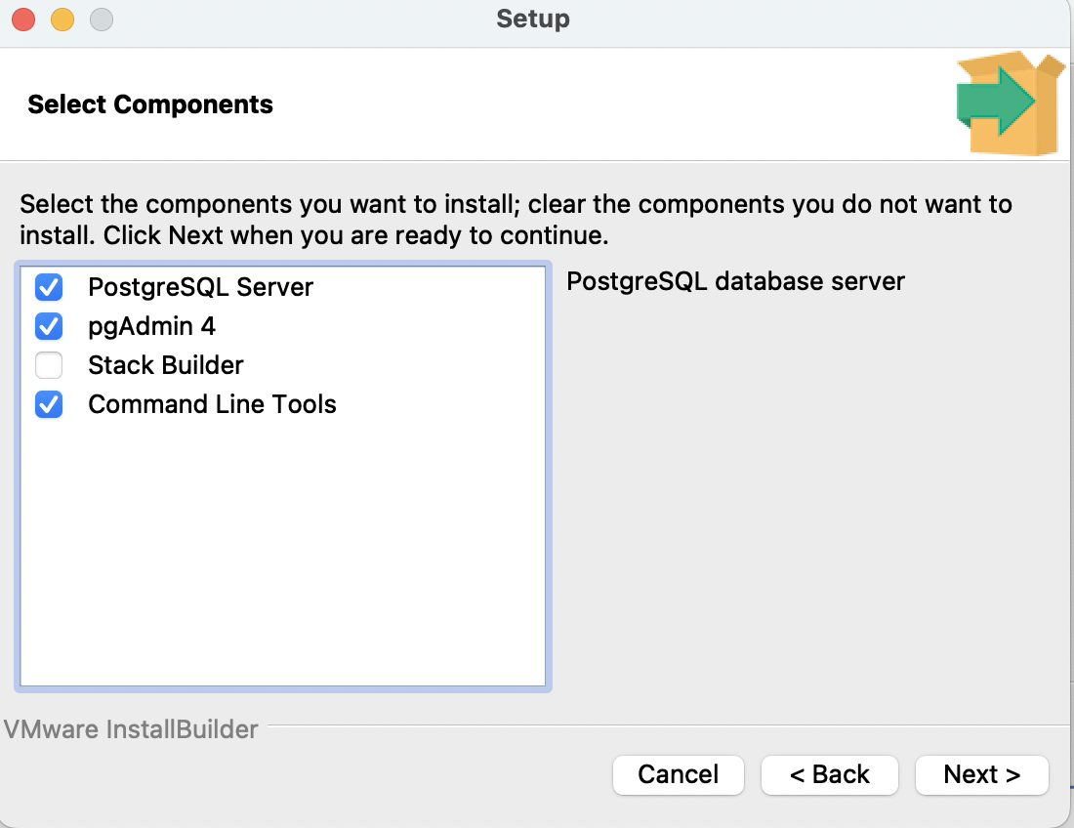

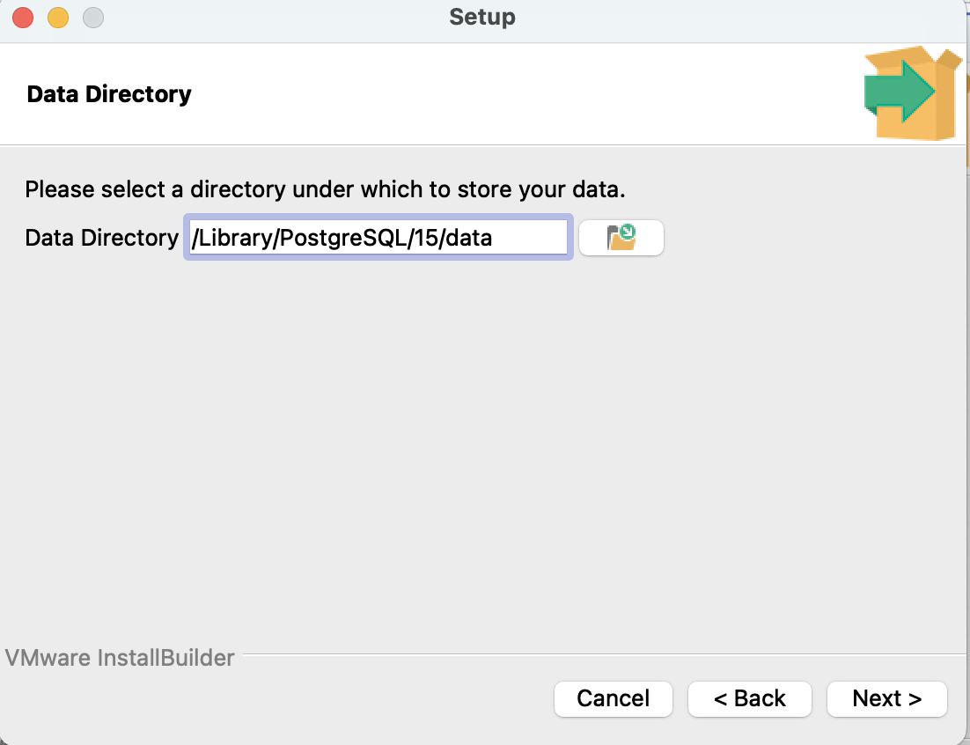

Set up and Password

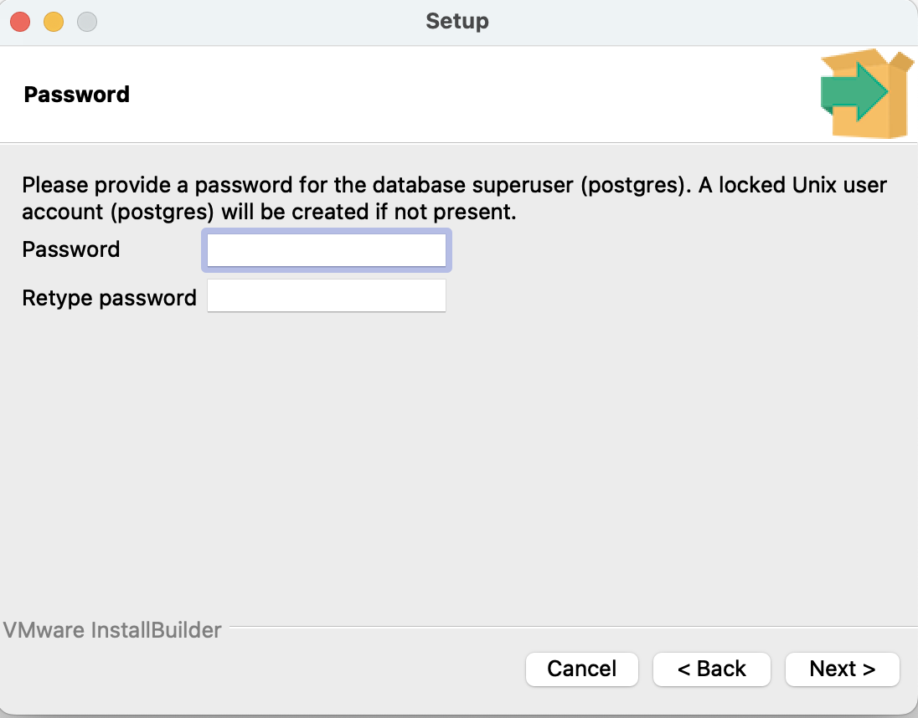

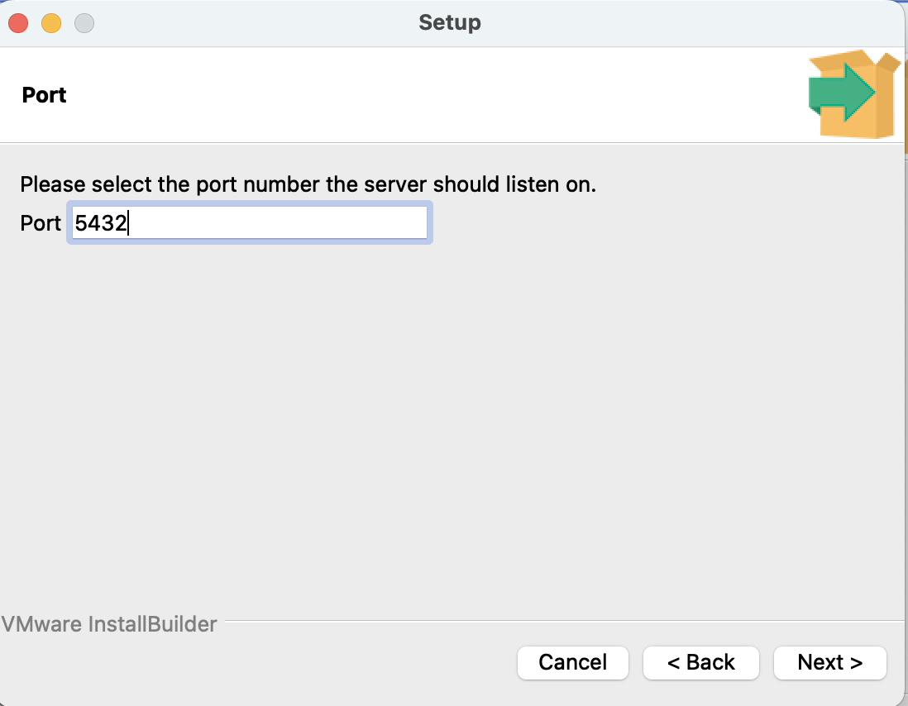

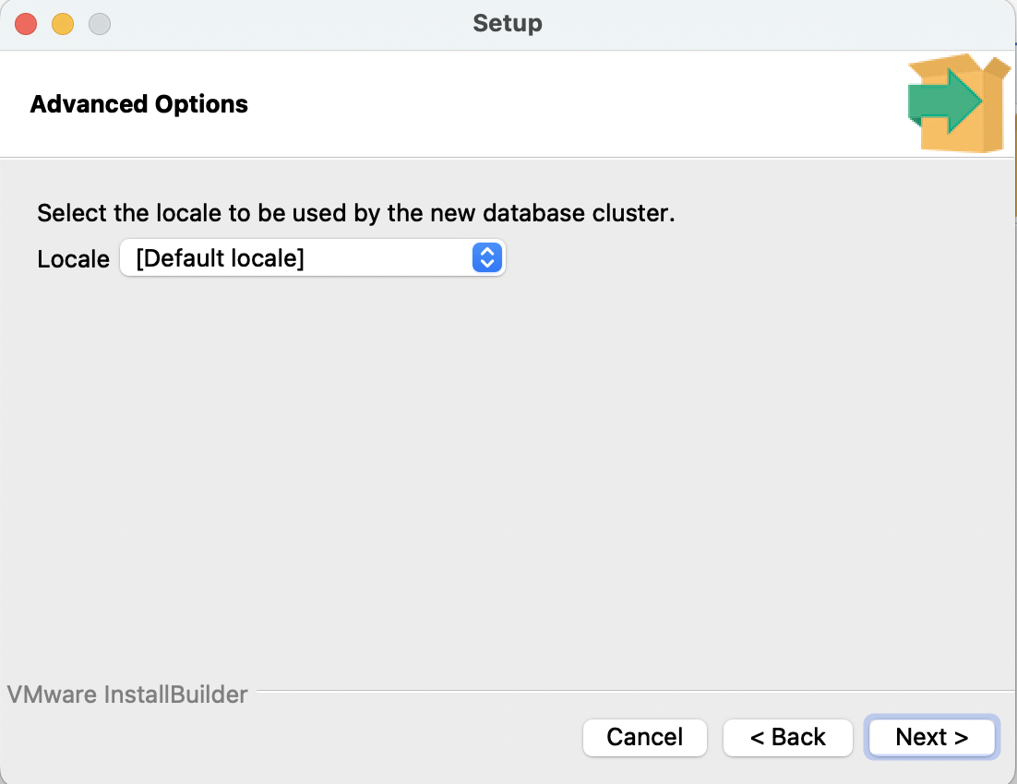

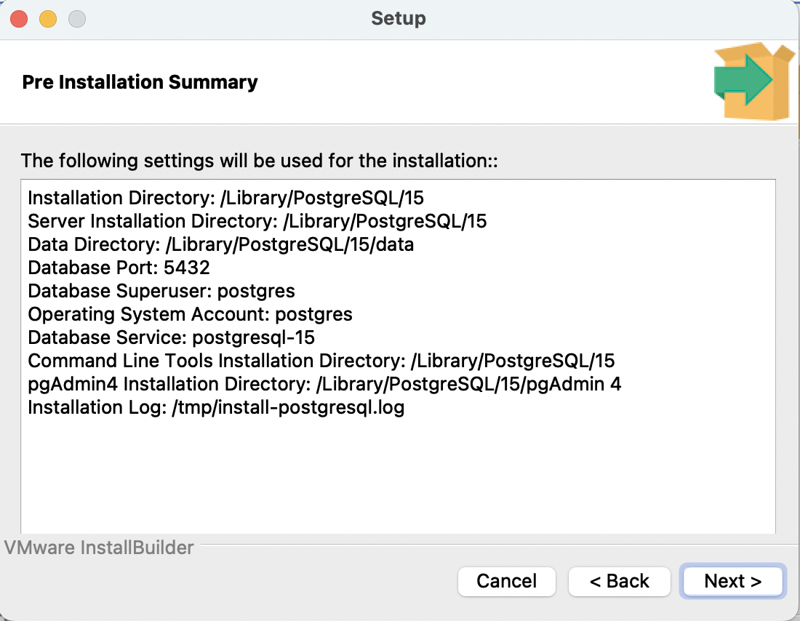

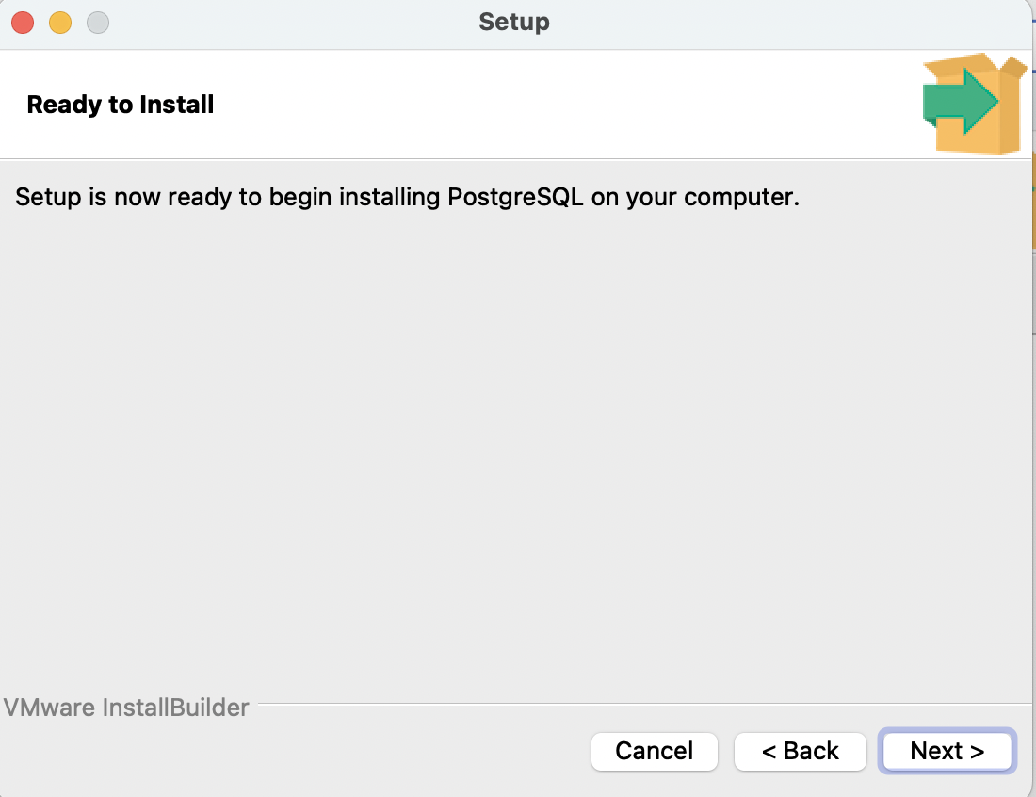

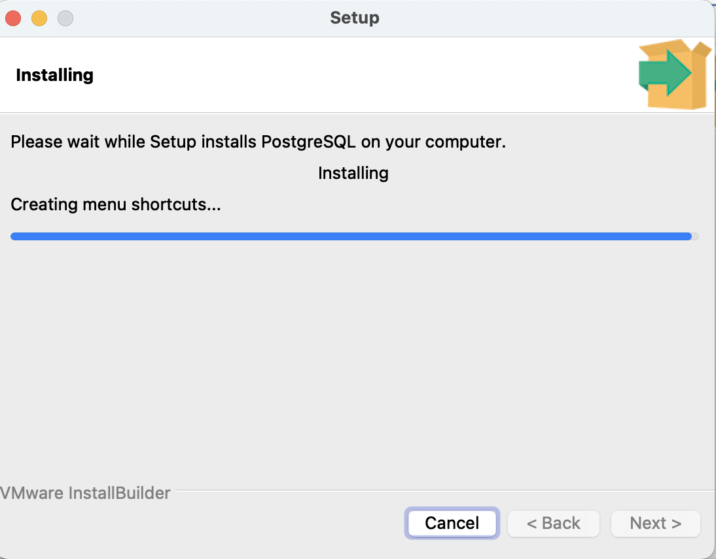

Click on the “Finish” button to complete the installation

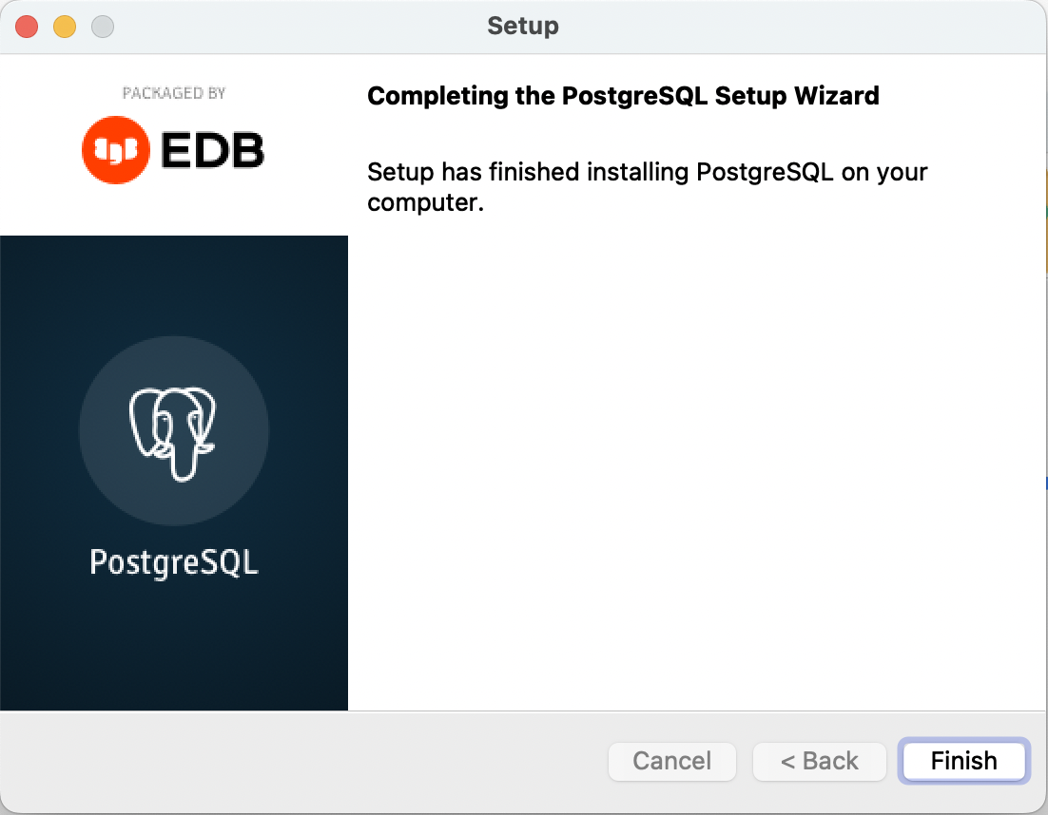

You will find the “pgAdmin 4” App in the list of applications.

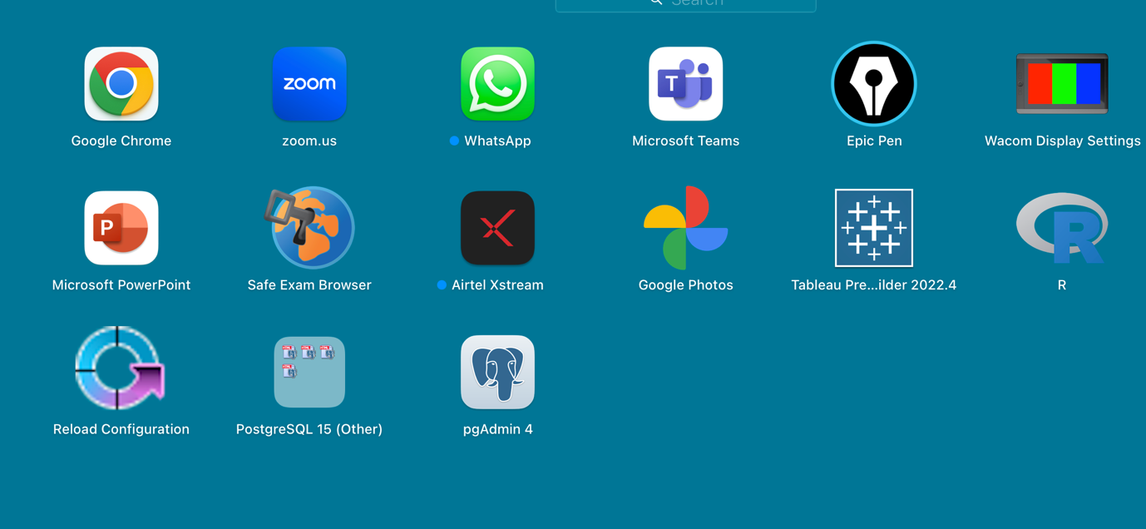

***How to set up the Binary Path***

First we need to fetch the path to the Bin, for which go to the “Go” option and select “Computer”

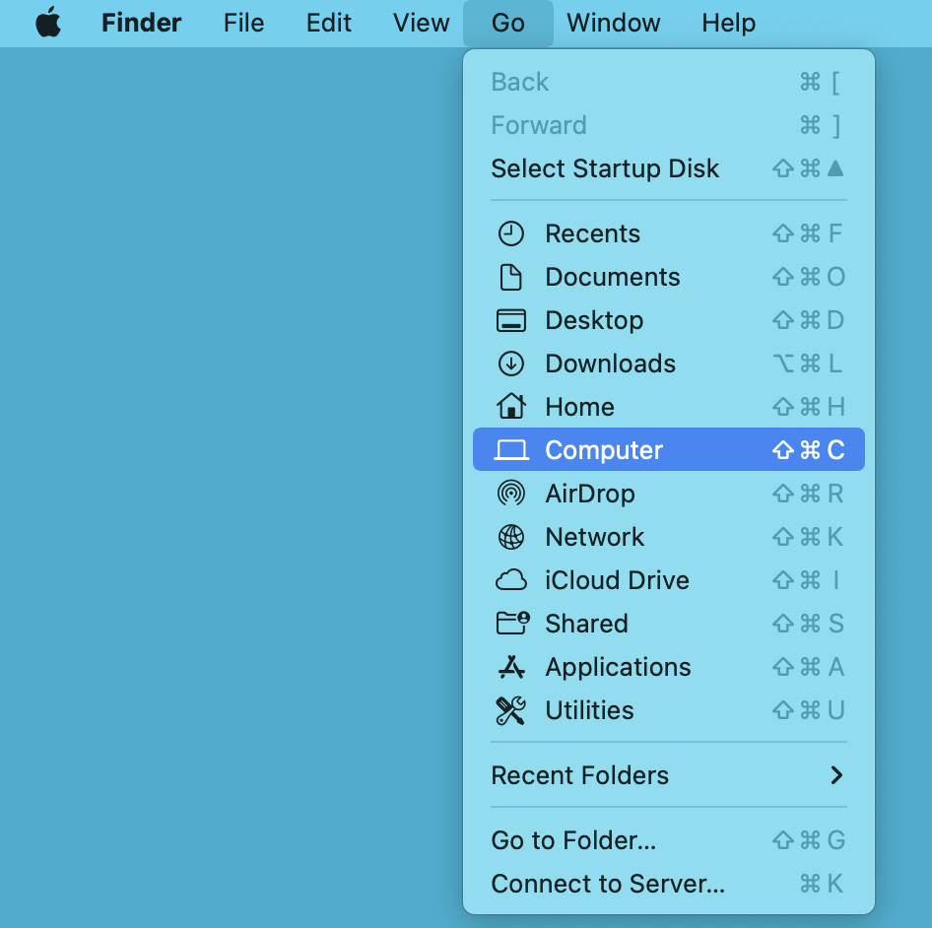

Double click on Macintosh HD

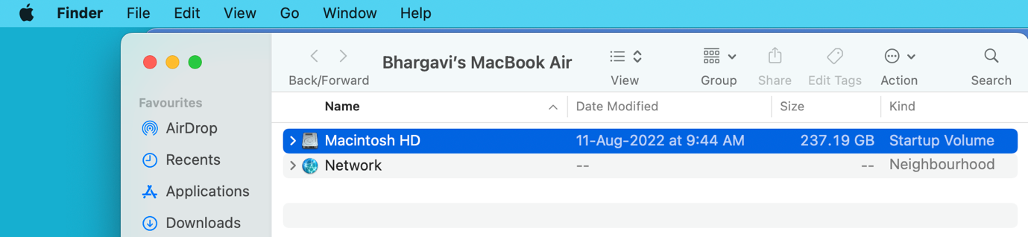

Double click on “Library”

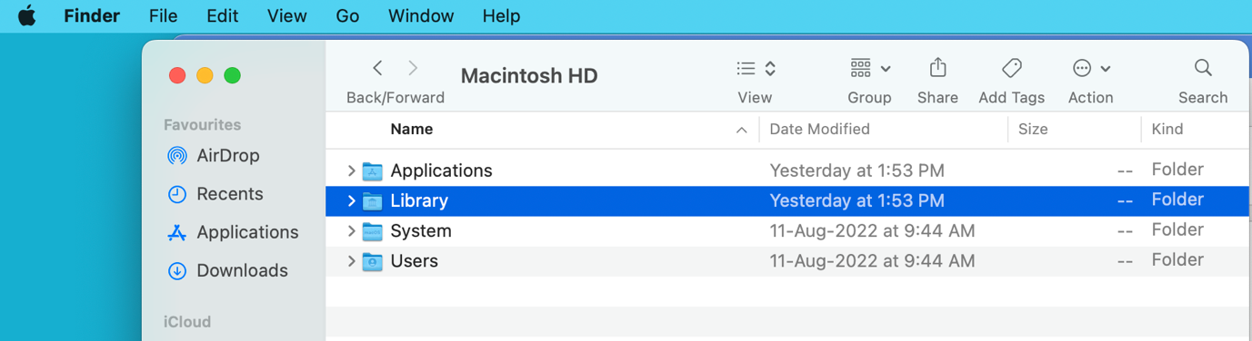

Scroll down and select PostgreSQL, double click.

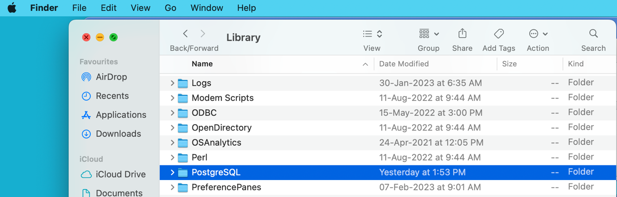

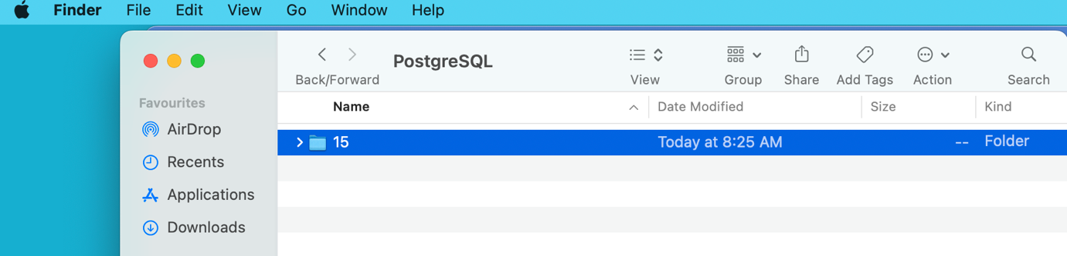

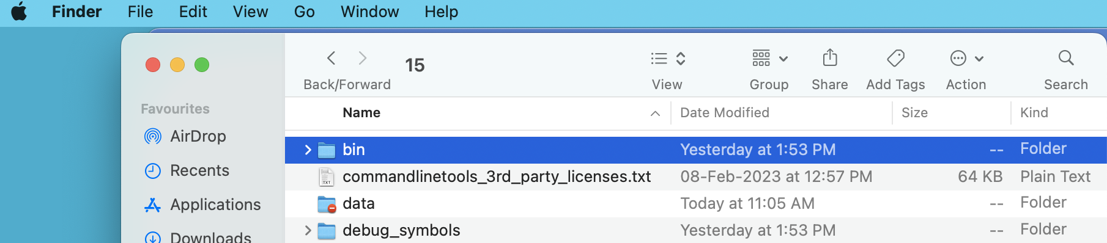

Double click on postgres and open it

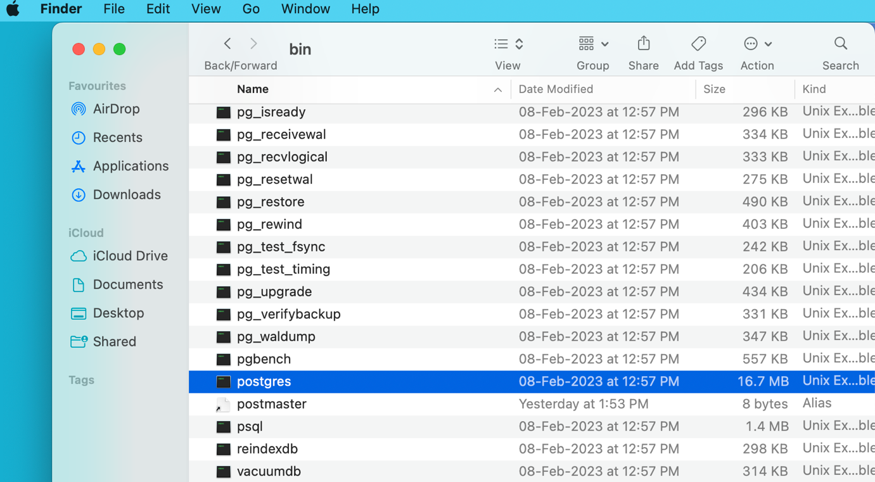

Copy the Binary Path from the text pad

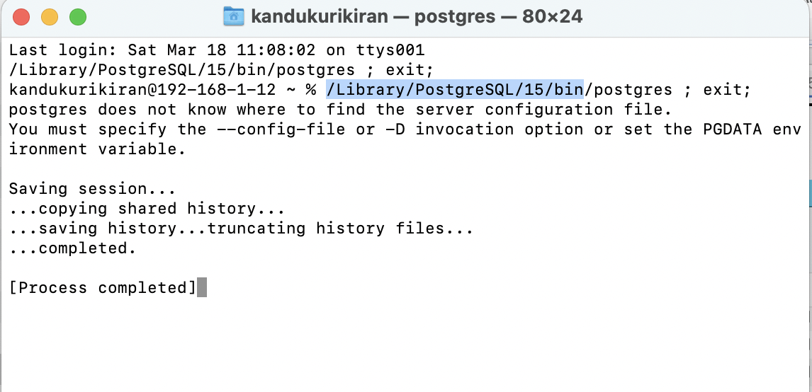

Close all the files.

Go to pgAdmin tool, click on the pgAdmin4 at the top left corner as shown –

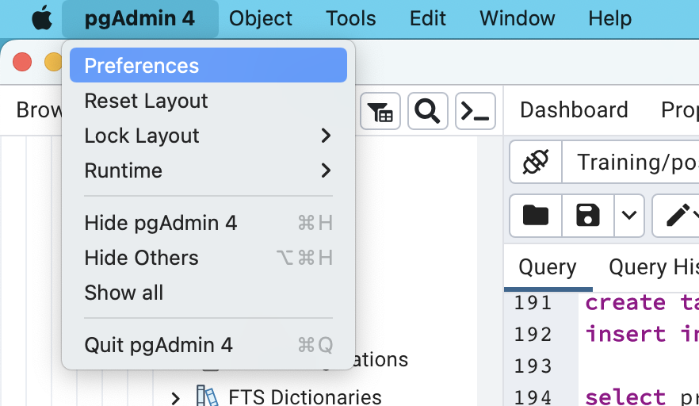

Scroll down to reach the Binary path option and select it, on the right side scroll down and paste the path as shown. Then click on the “briefcase icon with a check mark” to validate.

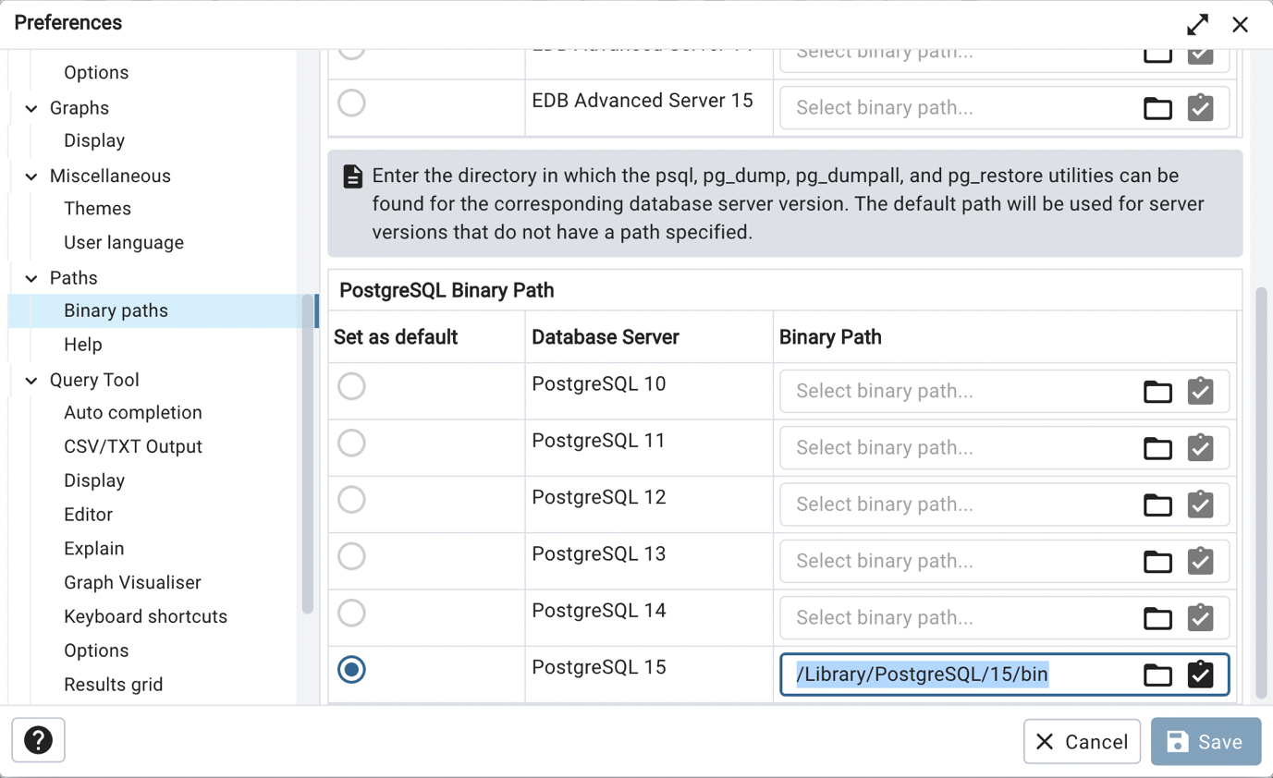

Click on the save button and close the window. You can now start importing the data into PostgreSQL server.